Project Design Phase-II

Data Flow Diagram & User Stories

|  |  |
| --- | --- |
| Date | February 2024 |
| Team ID | Team-591930 |
| Project Name | Predicting Mental Health Illness Of Working Professionals Using Machine Learning |
|  |  |

# Data Flow Diagrams:

A Data Flow Diagram (DFD) is a traditional visual representation of the information flows within a system. A neat and clear DFD can depict the right amount of the system requirement graphically. It shows how data enters and leaves the system, what changes the information, and where data is stored.

# Example: [(Simplified)](https://developer.ibm.com/patterns/visualize-unstructured-text/)

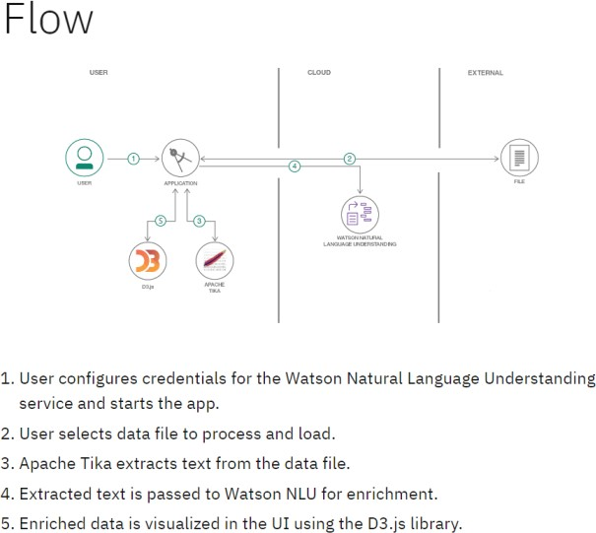

**Data Flow Diagrams:**

Project: "Predicting Mental Health Illness of Working Professionals Using Machine Learning"

+------------------------------------------+

| System Boundary |

+------------------------------------------+

| |

| |

+--------------------------+-----------+-------------------------+

| |

V V

+-------------+ +-----------------+

| External | | External |

| Data | | Systems |

| Sources | | (e.g., HR |

| | | Systems, |

+-------------+ | Database) |

| |

| |

V |

+------------------------------------------------------------------+

| Data Acquisition |

| & Integration |

+------------------------------------------------------------------+

| |

| |

V |

+------------------------------------------------------------------+

| Data Preprocessing |

+------------------------------------------------------------------+

| |

| |

V |

+------------------------------------------------------------------+

| Feature Engineering |

+------------------------------------------------------------------+

| |

| |

V |

+------------------------------------------------------------------+

| Model Development |

+------------------------------------------------------------------+

| |

| |

V |

+------------------------------------------------------------------+

| Model Evaluation |

+------------------------------------------------------------------+

| |

| |

V |

+------------------------------------------------------------------+

| Model Deployment |

+------------------------------------------------------------------+

| |

| |

V |

+------------------------------------------------------------------+

| User Interface |

+------------------------------------------------------------------+

**User Stories**

Use the below template to list all the user stories for the product.

|  |  |  |  |  |  |  |
| --- | --- | --- | --- | --- | --- | --- |
| **User Type** | **Functional**  **Requirement (Epic)** | **User Story Number** | **User Story / Task** | **Acceptance criteria** | **Priority** | **Release** |
| Customer (Mobile user) | Prediction Accessibility | PS-001 | As a mobile user, I want to access the mental health prediction tool on my smartphone. | - The prediction tool is accessible via a mobile-friendly web application.  - Users can input their data easily using the mobile interface.  - The predictions are displayed clearly on the mobile screen. | High | Version 1.0 |
| Customer (Web user) | Prediction Accessibility | PS-002 | As a web user, I want to access the mental health prediction tool on my desktop browser. | - The prediction tool is accessible via a web browser on desktop devices.  - Users can input their data conveniently using the web interface.  - The predictions are displayed clearly on the web page. | High | Version 1.0 |
| Customer Care Executive | Prediction Review | PS-003 | As a customer care executive, I want to review the mental health predictions for employees. | - There is a dashboard where customer care executives can view predictions for multiple employees.  - Executives can filter predictions based on various criteria such as department or risk level.  - The predictions include explanations or insights for easy interpretation. | Medium | Version 1.1 |
| Administrator | Data Management | PS-004 | As an administrator, I want to manage the data used for mental health prediction. | - There is an admin panel where administrators can upload, update, and delete employee data.  - Administrators can configure data sources and integration settings.  - The system ensures data privacy and compliance with regulations. | High | Version 1.1 |
|  |  |  |  |  |  |  |
|  |  |  |  |  |  |  |
|  |  |  |  |  |  |  |
|  |  |  |  |  |  |  |
|  |  |  |  |  |  |  |
|  |  |  |  |  |  |  |
|  |  |  |  |  |  |  |
|  |  |  |  |  |  |  |